**Global Vaccine Action Plan**

*Secretariat Annual Report 2016*

*Priority Country report on progress towards*

*GVAP-RVAP goals*

**UGANDA**

1. **Progress towards achievement of GVAP goals**
2. **Summary**

This summary table describes the current situation in Uganda regarding achieving the GVAP goals. Data used to assess progress towards achievement of GVAP goals are included in the annex (Country immunization profile).

| **Area** | **Indicator** | **Data for Uganda** |
| --- | --- | --- |
| **6. Reach 90% national coverage and 80% coverage in every district with all vaccines in national immunization programme** | **National coverage (2015 WUENIC)** | **BCG: 93 DTP3-HepB3-Hib3: 78 MCV1: 82 PCV3: 66 Polio3: 82** |

**3.3 Goal 3: Meet vaccination coverage targets**

* 1. **Achieve 90% national coverage and 80% coverage in every district with all vaccines included in the national schedule**

These targets have largely not been met. The WUENIC estimates for the third dose of pentavalent (DPT-HepB-Hib) vaccine have been 78% national for the past three years (2012 to 2014), and slightly down from 82% in 2011, with an estimated drop-out rate between the first and third doses of 12% nationally. However, according to data from the Joint Report Format, the country is close to meeting the district target, with 86% of districts having achieved 80% or greater coverage for three pentavalent doses. There are no district-specific WUENIC estimates, however, and the JRF data are based largely on administrative data, so caution should be taken in reading these statistics. A coverage survey is currently underway, which should provide a more accurate picture of both national and district-level immunization coverage.

According to the 2015 WUENIC estimates, the 90% national coverage goal has been achieved for BCG (93%), but was 82% for three polio doses, 82% for measles, and 66% for PCV3, which was introduced over a period of a year in 2013 and 2014. District-level WUENIC estimates for these vaccines (to determine the percent of districts reaching 80% coverage) are not available.

An assessment of equity of immunization coverage by geographic areas, income level and other variable is currently taking place.

Key factors affecting UNEPI’s ability to reach its coverage targets include:

* **Insufficient availability of static immunization services**: While national policy requires that all health facilities with refrigerators offer immunization services on a daily basis, the 2015 Comprehensive EPI, surveillance and immunization financing review (referred to as the “EPI review” in this document) found that only 40% of the 55 health facilities visited provided EPI daily, 18% had sessions 2-3 times a week, and 58% provided only one session per week. This is despite the fact that most facilities (88%), including hospitals and health centers levels II-IV, had working refrigerators. A key factor is staff shortages, making it difficult for health clinics to provide daily immunization along with all of the other services in the minimum health services package. One informant fears that adding more vaccines to the immunization schedule will make it even more difficult for health facilities to provide all vaccines on schedule. Another factor is spotty social mobilization, especially for routine immunization, affecting demand, especially for subsequent vaccine doses.
* **Insufficient outreach activities in many areas and inadequate implementation of Reach Every Community (REC) strategies**: Outreach activities were found to be irregular and insufficient in many sites included in the EPI Review. The shortage of health workers is a key reason; many facilities have only two or so qualified personnel and thus conducting outreach activities (which usually require at least two staff members) means closing down the clinic. The lack of transport and fuel due to insufficient PHC grant funds is another key factor. The 2015 GAVI Full Country Evaluation for Uganda found that only around 10% of Health Centres II had access to any vehicle for vaccination, while the rate was around 45% and 60% for Health Centres II and IV, respectively.[1] The EPI Review found that only 20% of health facilities had REC microplans, as did only 8 out of 112 districts. Poor implementation of REC/RED is reportedly due to insufficient training of health workers in microplanning, high health worker attrition rates, resulting in many workers not knowledgeable in microplanning, and a lack of funding to carry out microplanning activities.
* **Vaccine shortages or stock outs at the local level**: The transition of responsibility for the storage and distribution of vaccines from UNEPI to the National Medical Stores (NMS) in 2012/13 has been completed, and after initial problems, the system was deemed “robust” since April 2014[2] and the time it takes for vaccines to reach all districts from the central level has been cut in half (to two weeks). Nonetheless, 71% of health facilities and 96% of districts in the 2015 EPI review reported at least one vaccine stock out in the previous three months, especially PCV and BCG. While a global shortage of BCG contributed to the stock outs of this vaccine, other contributing factors for local vaccine stock outs are poor vaccine forecasting (especially denominator issues), lack of adequate cold storage space in some district stores, and perhaps most importantly, the continuing need for health facilities to collect vaccine from the district stores and their difficulty in doing so due to the lack of vehicles and fuel discussed above. “Last mile” vaccine delivery will therefore require additional funding.
* **Insufficient monitoring and supportive supervision**: A supervision infrastructure is in place, with EPI Coordinators in each district and some sub-districts. However, regular supervision is lacking in many areas, due to insufficient funds and transportation to make supervisory visits. In addition, the EPI review found that defaulting tracking was occurring regularly in only 38% of health facilities. However, the situation is improving with the establishment of Regional Supportive Supervision Teams, starting in 2015. The teams, described in the last section of this report, are already operating in 11 of the country’s 14 regions, with funding from the polio program (and the HSS grant in the future).

The EPI Revitalization Plan, enacted by the Government from 2012 to 2014 in response to declining or plateauing coverage rates and disease outbreaks, has demonstrated that many of these issues and bottlenecks can be resolved with an infusion of funds and attention. With funding from many partners, the plan focused on improving coverage in poor-performing districts by providing the means with which to strengthen social mobilization, outreach activities, vaccine collection from district stores, supervision and the like (see description in the last section). Administrative coverage data show an increase in coverage between 2010 and 2015, which many attribute in large measure to the plan (see maps in annex).[3]

**ANNEX: Country immunization profile**

1. **Immunization coverage and equity**

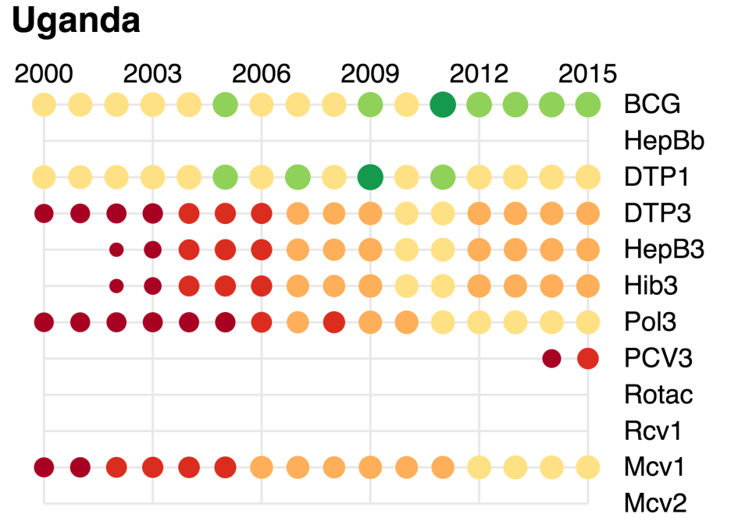

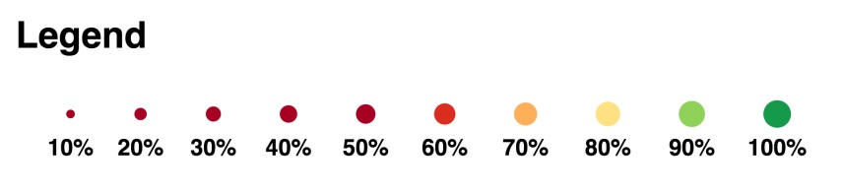

1. GAVI Full Country Evaluation, 2015 annual dissemination report, Uganda report.
2. cMYP.
3. Note that the WUENIC estimates for those years to not reflect these reported increases in coverage over this period and the WUENIC estimates are currently being challenged.